Week 7 - Machine Learning Basics Report

Name : Swayam Rudrawar

Objective:
The objective of this activity was to learn the fundamentals of supervised machine learning and apply them to the light intensity datasets collected in the previous weeks. The cleaned Bright, Dim and Dark datasets were prepared for model training. Two classification algorithms, K-Nearest Neighbors (KNN) and Decision Tree, were trained and evaluated to classify the light intensity into Bright, Dim and Dark categories.

Software and Libraries Used:
- Python
- Colab
- Pandas
- NumPy
- Scikit-learn
- Matplotlib
- Seaborn

Workflow:
Cleaned Datasets → Combined Dataset → Feature Selection → Train/Test Split → KNN Model → Decision Tree Model → Performance Evaluation → Model Saving

Tasks Performed:
- Imported the cleaned Bright, Dim and Dark datasets.
- Combined all datasets into a single machine learning dataset.
- Prepared input features (Lux and Smoothed Lux).
- Applied label encoding for class labels.
- Split the dataset into training and testing sets.
- Trained KNN and Decision Tree classification models.
- Evaluated both models using Accuracy, Precision, Recall and F1-score.
- Generated confusion matrices and accuracy comparison graph.
- Saved trained models as .pkl files.

Model Performance Summary:
Model | Accuracy | Precision | Recall | F1-Score
KNN | 97.61% | 0.98 | 0.98 | 0.98
Decision Tree | 97.81% | 0.98 | 0.98 | 0.98

KNN Classification Report:
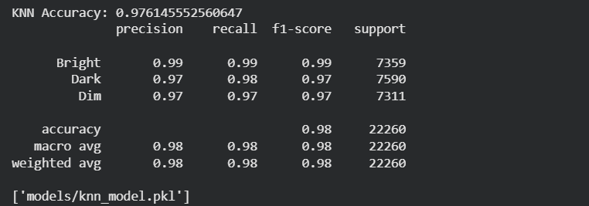

Decision Tree Classification Report:
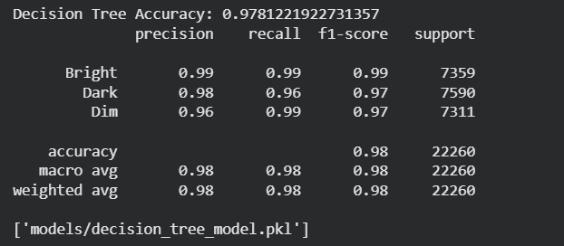

Confusion Matrix:
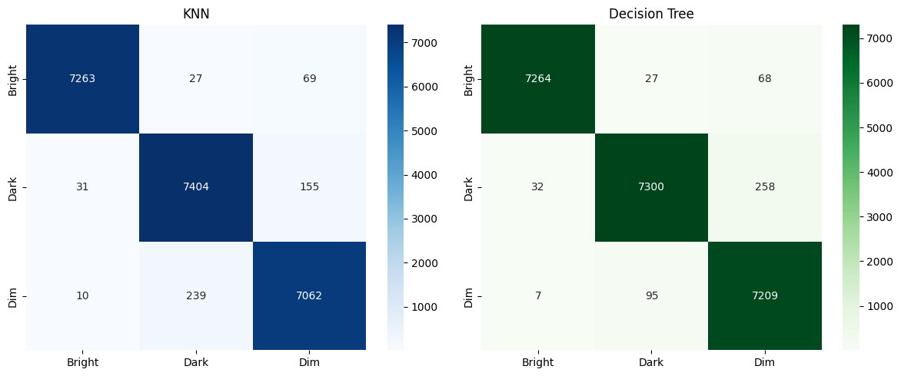

Model Accuracy Comparison:
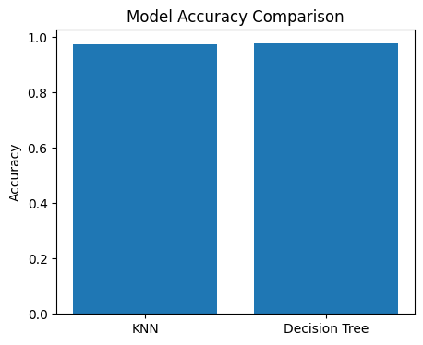

Decision Tree Visualization:
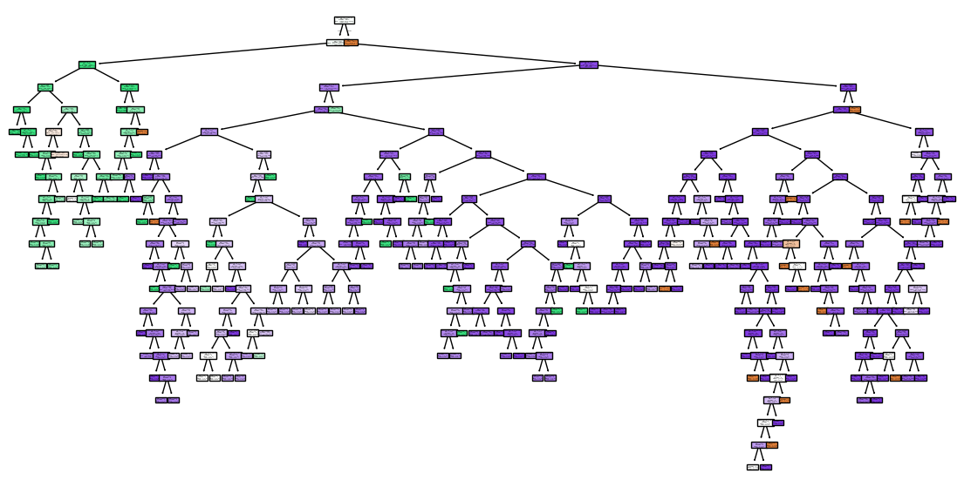

Observations:
- KNN achieved an accuracy of 97.61%.
- Decision Tree achieved an accuracy of 97.81%, making it the better-performing model.
- Both models showed excellent precision, recall and F1-score values.
- The confusion matrices indicated that most samples were correctly classified.
- The trained models were successfully saved and are ready for future prediction tasks.

Conclusion:
The objectives of Week 7 were successfully completed. The prepared light intensity dataset was used to train and evaluate two supervised learning models. Both KNN and Decision Tree achieved high classification accuracy, demonstrating that the collected sensor data is suitable for intelligent monitoring applications. The saved machine learning models can be integrated into the next stages of the project for real-time prediction and deployment.

